Purpose: The purpose of this job aid is to help you create or deactivate an Account Delegate in KFS. An Account Delegate is a person who is given permission to act as a proxy in the absence of the Fiscal Officer on an account. In this job aid, you will learn about:

What is an Account Delegate 1
Account Delegate Attributes 1
Creating an Account Delegate 2
Deactivating an Account Delegate 4
Receiving Notifications as an Account Delegate 6
Viewing an Account Delegate Action List 7
Receiving Notifications as a Fiscal Officer 8
Route Log 8

What is an Account Delegate
The Account Delegate takes on the role of the Fiscal Officer in their absence on designated accounts for KFS documents and Procurement documents (Req System, cyBUY, and P-Card). For Disbursement Vouchers and Noncheck Disbursements, the Account Delegate acts as the approver when the fiscal officer is the originator. KFS documents allow an infinite amount of delegates, however, the Procurement documents only allow two delegates (if more than two are assigned, the system selects the lowest two UID’s assigned to KFS delegates or PUR delegates).

Account Delegate Attributes
The table below lists and describes the main properties associated with an Account Delegate eDoc. Required fields on the screen are denoted by an asterisk (*) table:

Field Name | Description
Document Overview
Description* | The name of the Account Delegate and account number selected to act as backup for the account.
Explanation* | The Account Number should be listed here along with the business purpose. Although an Explanation is not required in KFS, it is required by the Controller’s Department.
Organization Document Number | This item is not needed to create or deactivate an Account Delegate but can be used for departmental reference.
Edit Account Delegate
Chart Code* | IS – Iowa State University is the code by default. Must be all CAPS with no punctuation or spaces.
Account Number* | The existing 7-digit Account Number on which the Account Delegate needs to take action.
Document Type Name* | For this field, type in “KFS” for KFS documents and Procurement documents if the approvers are the same. If the approvers for Procurement documents (Req System, cyBUY, P-Card) are different than KFS documents type “PUR”. Must use all CAPS with no punctuation or spaces.
Account Delegate Active | This box is checked by default if the Account Delegate is active but can be made inactive. For more details see Deactivating an Account Delegate below.
Account Delegate Start Date* | The calendar defaults to the current date. Use the calendar icon to choose a future date for the Account Delegate responsibilities to begin if needed.

Creating an Account Delegate
Use these steps to create an account delegate.

- Select Account Delegate under Chart of Accounts on the KFS Main Menu. | 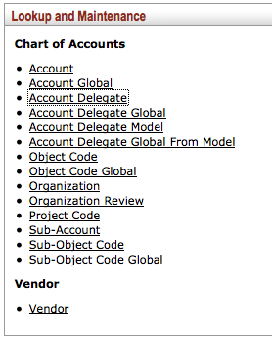

- Click Create New on the top right side of the Account Delegate Lookup screen. | 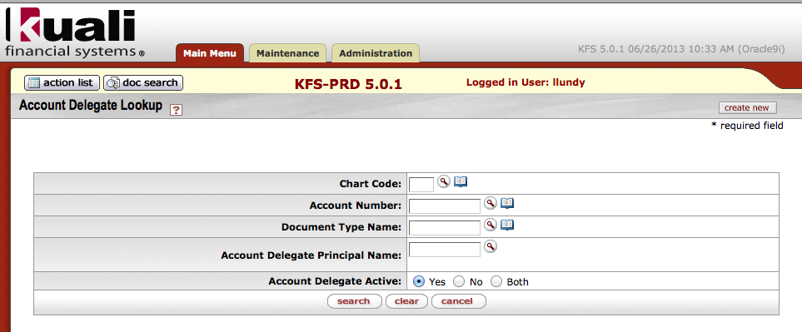

- Enter the Account Delegate’s name and account number for the description on the Account Delegate screen.  - Type in the business purpose and account number for the Explanation. | 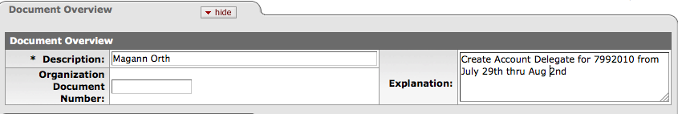

- Enter IS for the Chart Code.  - Enter the Account Number for which you will delegate responsibility.  - Enter KFS as the Document Type Name for KFS and Procurement documents if the approvers are the same for both types. Enter PUR as the Document Type Name for Procurement documents (Req System, cyBuy, P-Card) if the approvers are different than KFS documents (limitation of two delegates for Procurement documents)  - Enter the Account Delegate’s NetID for the Account Delegate Principal Name or look it up using the looking glass icon. | 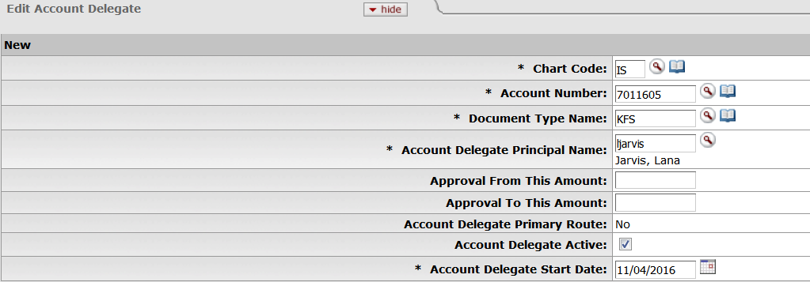
- Leave Account Delegate Active Box checked.  - Click the calendar icon to choose an Account Delegate Start Date or leave the current date to make it effective immediately. | 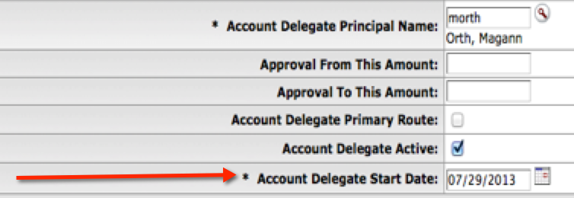

Steps 11-14 Optional – To notify a user about Account Delegate responsibilities:

- Click show on the Ad Hoc Recipients tab.  - Select FYI from the Action Requested drop down box.  - Type the Account Delegate’s NetID in the Person box.  - Click Add in the Actions box to add this request. | 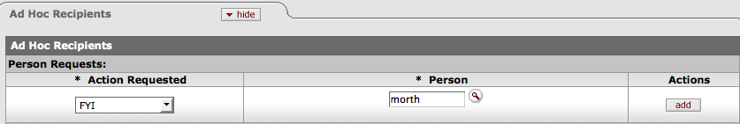

- Click Submit to route document to the Fiscal Officer on the account.

Deactivating an Account Delegate
To deactivate an Account Delegate, you will need to begin at the Account Delegate Lookup screen.
- Click Account Delegate under Chart of Accounts on the KFS Main Menu.

- Enter the IS for the Chart Code.

- Enter the Account Number or the account delegate principal name on the Account Delegate Lookup screen then click Search.

- Click Edit next to person you want to change. | 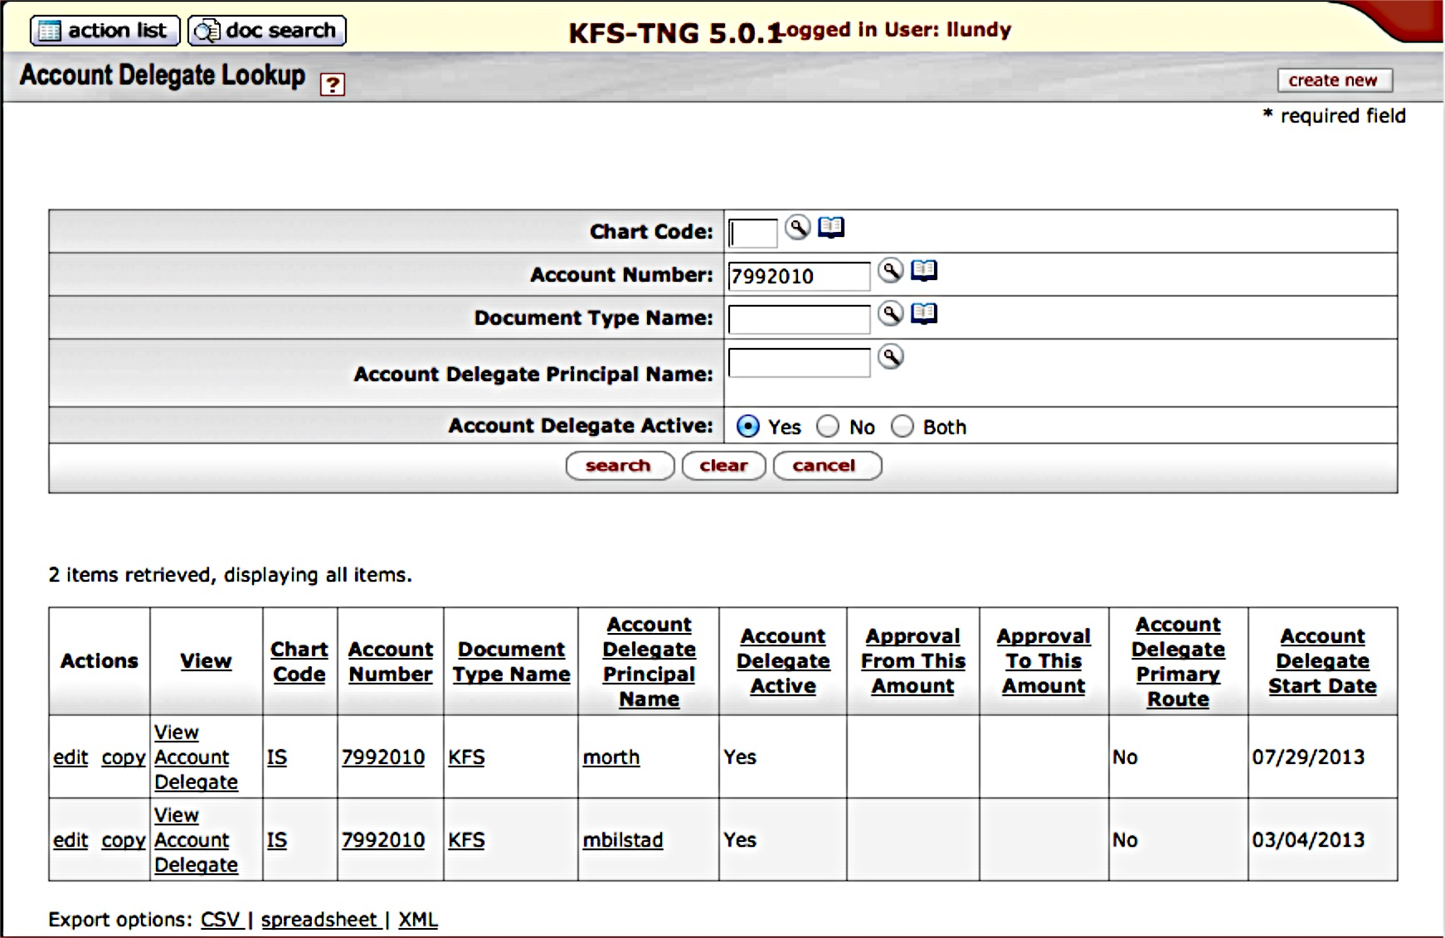

- Enter the Account Delegate’s name and account number in the Description and reason for the change in the Explanation.  - Uncheck the Account Delegate Active box to deactivate your current Account Delegate. | 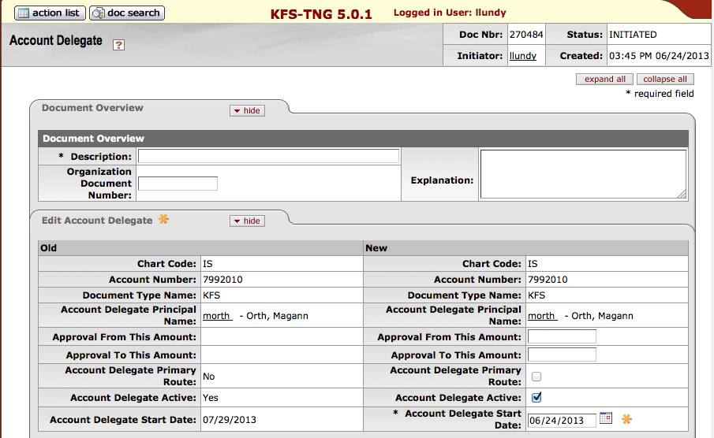

- Click Show on the Ad Hoc Recipients tab.

Optional: Notification to the former Account Delegate.

- Select FYI from the Action Requested drop down box.

- Type the Account Delegate’s NetID in the Person box.

- Click Add in the Actions box to add this request.

- Click Submit to route to the Fiscal Officer on the account.

Receiving Notifications as an Account Delegate
To receive notifications about Accounts for which you may be a delegate, you will need to turn on your Workflow Preferences in your Action List (this only applies to KFS documents not Procurement documents).

- Click the Action List button on the KFS Main Menu to access the Action List screen.  - Click the Preferences button on the top right of the Action List screen to change your settings. | 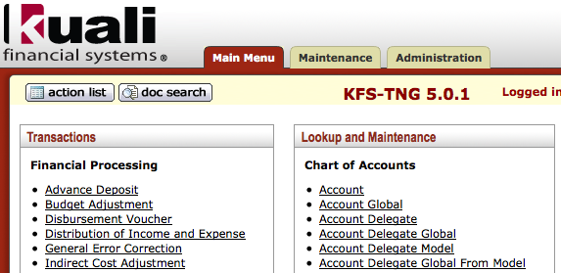  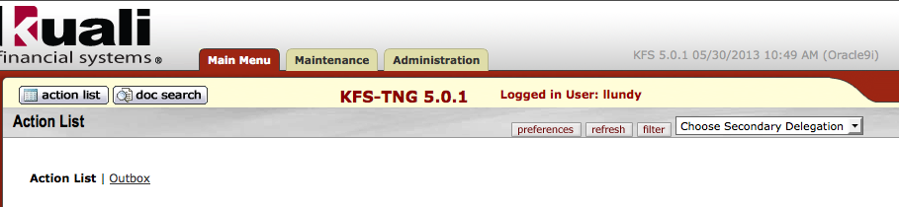

- Scroll down to the Email Notification Preferences tab.  - Check the Receive Secondary Delegate Emails box. | 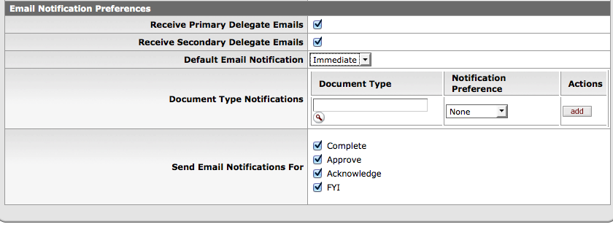

- Click Save.

Viewing an Account Delegate Action List
To view actions for an account for which you are the delegate (this only applies to KFS documents not Procurement documents):

- Click the Choose Secondary Delegation drop down menu to select the name of the delegator requesting that you take action.  - Click the Id link to open the document created. | 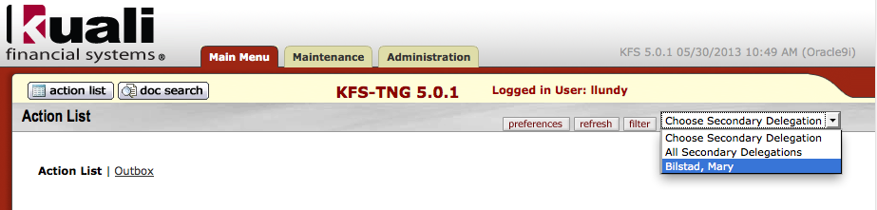  1  2  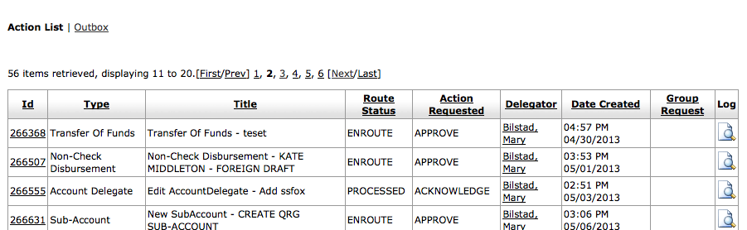
- Scroll to the bottom of the selected document and click approve or disapprove.

Receiving Notifications as a Fiscal Officer for KFS documents
When an Account Delegate initiates a KFS eDoc, it will not route to the Fiscal Officer (FO) on the Account since the system views the delegate as acting on behalf of the FO. However, if the FO wants to approve the eDoc, the delegate must go to the Routing Log tab before submitting the eDoc to send an Ad Hoc Recipient notice to the FO. An exception is the disbursement voucher and the non-check disbursements these eDocs require an approval.

Route Log for KFS documents
Since the initiator is the Fiscal Officer, the Route Log will show the action taken as completed once a transaction is successfully submitted.

