Purpose: The purpose of this job aid is to help you create and edit an Account Delegate Global in KFS. In this job aid, you will learn about:

What is an Account Delegate 1
Why Use an Account Delegate Global 1
Account Delegate Global Attributes 1
Creating an Account Delegate Global 2
Editing an Account Delegate 3
Adding Delegates for Multiple Accounts 3
Adding Multiple Account Lines 4

What is an Account Delegate
The Account Delegate takes the role of the Fiscal Officer in their absence on designated accounts for KFS documents and Procurement documents (Req System, cyBUY, and P-Card). For Disbursement Vouchers and Noncheck Disbursements, the Account Delegate acts as the approver when the Fiscal Officer is the originator. KFS documents allow an infinite amount of delegates, however the Procurement documents only allow two delegates (if more than two are assigned, the system selects the lowest two UID’s assigned to KFS delegates or PUR delegates).

Why Use an Account Delegate Global
An Account Delegate Global (GDLG) allows you to update the number of delegates you have using one eDoc. The GDLG can be used in several ways. You can use it to:
- Add one person on many Accounts
- Add many people on one Account
- Add many people on many Accounts
- Add delegates on more than one document type
- Remove existing delegates by replacing them with new delegates

Account Delegate Global Attributes
One important element of the GDLG is that it always replaces the existing values. It does not add values to the GDLG that currently exists. For example, if Mary is the current Account Delegate and you want to add John and Sue, you must add all three people on your GDLG.

There are two primary tabs on the GDLG:
- Edit Global Delegate tab used for selecting the people and document type(s) to receive the delegations
- Edit List of Accounts tab used for selecting the accounts requiring Delegates

The table below lists and describes the GDLG properties:

Field Name | Description
Document Overview tab
Description* | The names of the delegates and org codes should be listed here.
Explanation* | A business explanation and account numbers should be listed here. Although completing the Explanation field is not required in KFS, it is required by the Controller’s Department.
Organization Document Number | This item is not needed to add an account delegate but can be used for departmental reference.

Field Name | Description
Edit Global Delegate
Document Type Name* | For this field, type “KFS” for KFS documents and Procurement documents if the approvers are the same. If the approvers for Procurement documents (Req System, cyBUY, P-Card) are different than KFS documents enter “PUR”. Must use all CAPS with no punctuation or spaces.
Account Delegate Start Date* | Leave Account Delegate Start Date as-is unless the delegation will not start until sometime in the future.
Account Delegate Principal Name* | The Account Delegate ISU NetID. Use the looking glass to search for an employee’s NetID.
Edit List of Accounts
Chart Code* | Choose IS – Iowa State University. Must be all CAPS with no punctuation or spaces.
Account Number* | The Account Number that needs delegation.
Account Name* | The name that appears on the Accounting Lines tab in financial documents and reports (this field populates after account number is entered).

Creating an Account Delegate Global
- Follow these steps to create an account delegate global. Select Account Delegate Global under Chart of Accounts on the KFS Main Menu. | 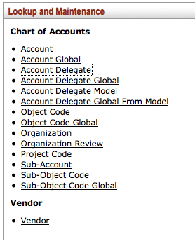

- Enter org code and net ids of the account delegate in the description on Account Delegate Screen.  - Type in the business purpose in the Explanation. | 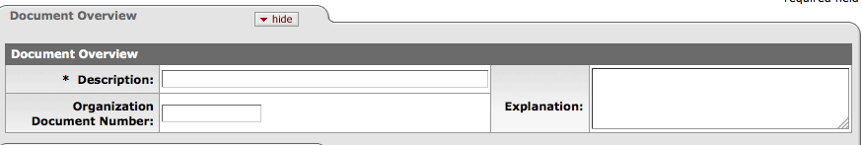
- Enter KFS as the Document Type Name for KFS documents and Procurement documents if approvers are the same for both types. Enter PUR as the Document Type Name for Procurement documents (Req System, cyBUY, P-Card) if the approvers are different than KFS documents (limitation of two delegates for Procurement documents).  - Leave Account Delegate Start Date as-is unless the delegation will begin at a future date.  - Enter the first Account Delegate’s NetID in the Account Delegate Principal Name or look it up using the looking glass icon.  - Click the Add button.  Note: Repeat steps 4-8 to add the rest of your Account Delegates. |  | 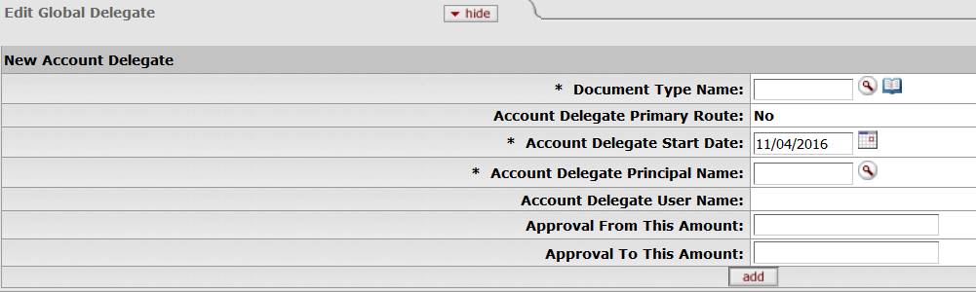

Editing an Account Delegate
There is no way to remove a delegate from multiple accounts. To override your existing delegates, create a new GDLG that includes only the people who should be delegates, which will deactivate the old delegates.

Adding Delegates for Multiple Accounts
You can enter accounts one at a time. This is recommended if you have only a few accounts. If you are adding or changing the delegates for an entire department, you can add multiple accounts using Look Up/Add Multiple Account Lines.

To enter accounts one at a time.

- Select IS for chart code.  - Enter account number.  - Click Add.  Note: You can click outside of the Account Number box to make the Account Name appear. | 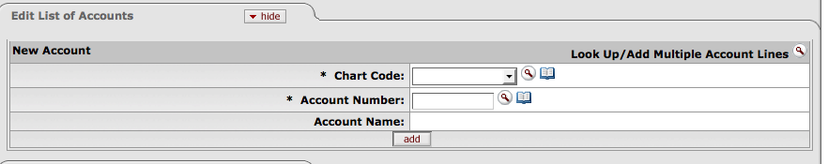
A new box appears under the Edit List of Accounts tab with the added Chart Code, Account Number and Account Name.  To add additional accounts repeat steps 1-3 above. | 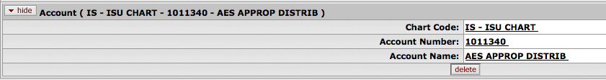

Adding Multiple Account Lines
To add several or all accounts for a department (organization):
Click the looking glass icon to Look Up/Add Multiple Account Lines.

This will take you to an Account Lookup screen.

Enter your Organization Code or the Fiscal Officer Principal Name on the Account Lookup screen then click the Search button.  Click Select All from All Pages to capture all of the Accounts under your Org Code and click Return Selected.  Or, you can check several boxes on the far left of the list and click Return Selected on the top right of the list to include specific Accounts. | 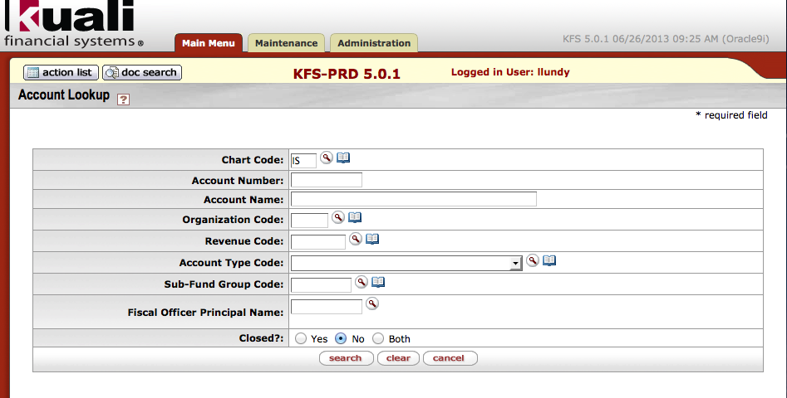  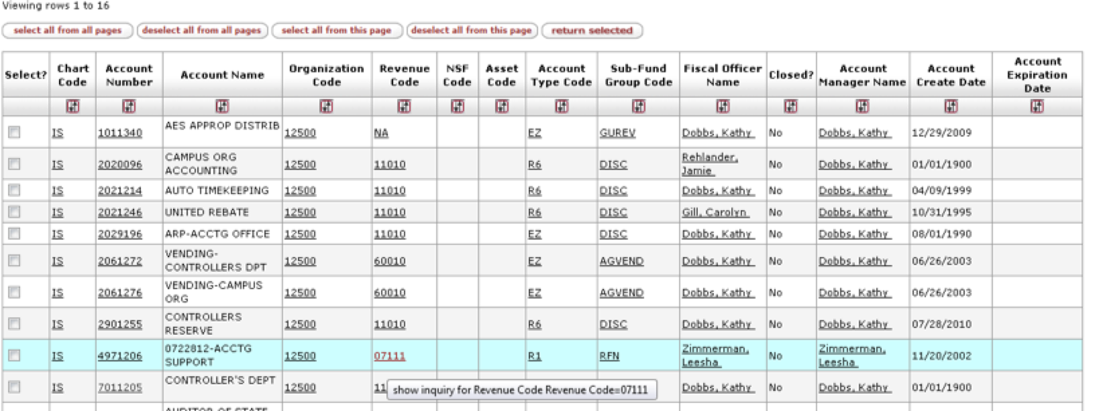

- Click show on the Ad Hoc Recipients tab.  - Select FYI from the Action Requested drop down box.  - Type the Account Delegate’s NetID in the Person box.  - Click Add in the Actions box to add this request.  - Click Submit to send FYI document to the Fiscal Officer(s) on the account(s) and Ad Hoc Recipient(s). |  | 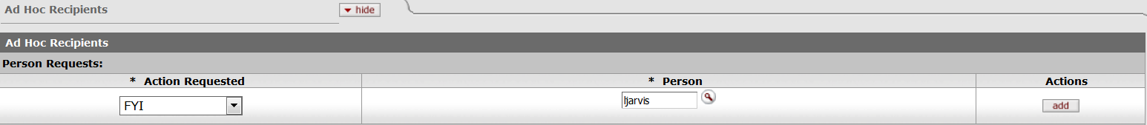
Steps 8-12 are optional- To notify a user about Account Delegate Responsibilities

